O Little Town

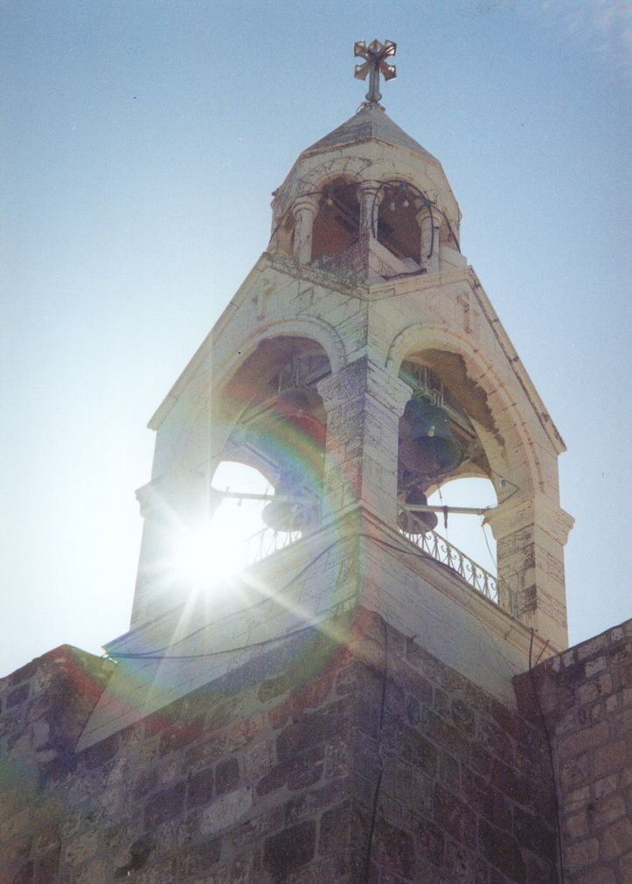
Christmas is coming. Tesco has had Christmas cards on sale since September, and the annual barrage of adverts for toys and other gift ideas hit our TV screens the second the last sparkler had sparkled its last. Very soon we will be singing all our favourite Christmas carols, conjuring up familiar images of swaddled babies, lowing cattle, and portentive stars twinkling over the Little Town of Bethlehem.

I have been fortunate enough to visit the ‘Little Town’ on two occasions. During both visits I found it almost impossible to relate the modern town to its biblical counterpart, and was left wondering what it must have been like in Mary and Joseph’s time; and how they, and their newborn child, might have fared in the Bethlehem of today.

Mary and Joseph were Jewish citizens of a territory occupied by the Roman army. Their journey to Bethlehem from Nazareth would have been hazardous and uncomfortable, but it appears, despite the military occupation, to have been relatively straightforward.

In a recent article Arjan El Fassad of the Palestine Right to Return Coalition asked, “What if Jesus had been born in our generation?” It is an interesting question.

Today Bethlehem is a Palestinian town in a territory occupied by the Israeli army. So let us imagine for a moment that Mary and Joseph are Palestinians and that today they had to leave Nazareth for their home town of Bethlehem. Would they, Arjan asks, manage to arrive in time for their son's birth? Would they arrive at all?

From Nazareth the direct route would take them south through the West Bank (biblical Judea and Samaria) - through Jenin, Nablus and Ramallah - then on through Jerusalem and finally to Bethlehem, which is now surrounded by the 8-metre-high Israeli ‘security wall’. It is not at all certain, unless they had the correct permits - which can take months to obtain - whether they would actually reach Bethlehem as access to the West Bank, even via mountainous paths and tracks, is severely restricted. All routes are either closed or heavily guarded by the Israeli army. Furthermore, within the West Bank itself, there are nearly 700 Israeli military checkpoints and unmanned roadblocks. If they did manage to reach the entry checkpoint into Bethlehem, Israeli solders may finally deny them access to the town, despite Mary clearly being in the final stages of pregnancy and needing to reach a hospital.

It is not uncommon for pregnant Palestinian women to be denied access to medical facilities. In his article Arjan goes on to relate the story of Fatima Abed Rabbo, who gave birth at an Israeli military checkpoint in Al Walaja village, near Bethlehem: “Fatima and her husband, Nasser, were trying to reach the hospital inside the town. Soldiers twice refused to allow them to pass, saying that Fatima's condition was not critical. After trying for about an hour to get through, Fatima gave birth to her son, Walid, in the car, at the checkpoint.

“Fatima was only seven months pregnant. As a premature baby, Walid required urgent medical attention. The family reached the hospital in Bethlehem one and a half hours after he was born. Walid weighed only 1.4 kilos, and his temperature was extremely low on arrival. He died that afternoon, though it is likely that he would have lived had he received immediate care.”

Last year I visited Al Walaja village and, by chance, met Fatima’s cousin. He told me Fatima is now doing well, but as the Israeli army has recently demolished twenty houses in the village, life continues to be difficult, and her family faces the very real threat of eviction from land they have inhabited for generations.

It’s quite difficult to imagine the Son of God being born on the back seat of a car, so let us assume that Mary and Joseph do make it into Bethlehem, and that Jesus is born without further trouble, in hospital.

So far so good.

If, however, the family needed to leave Bethlehem to escape persecution or further fighting would they be able to get out? Could they, today, flee to Egypt as refugees?

Bethlehem is home to thousands of Palestinian refugees, many of whose families have been living in camps there for three or four generations – since the war of 1948. Today’s young children of Bethlehem, equally as vulnerable as the ‘innocents’ of Jesus’ day, are trapped; they live only seven miles from Jerusalem, their holy city, their capital city, but most of them have never seen it. For them the ‘Little Town’ has become a large prison.

In the Deheishe refugee camp in Bethlehem I met Tamer, a Palestinian teenager who has lived there all his life. He said to me, “I don’t know who I am. My smile was lost in the war; my childhood has been stolen by the shooting.”

As Tamer showed me around the camp we came upon a trio of small children skipping along the road arm in arm singing a song in Arabic. I asked my young guide what the children were singing about. He said, “They are singing about the loss of their land”. The children were no more than six or seven years old; their land was lost over fifty years ago. But their grandparent’s experience was now theirs too - it was part of who they were.

It is unclear exactly how long after Jesus’ birth the Holy Family fled Bethlehem to escape Herod’s massacre. But that event, the journey into Egypt, and the whole experience of coping with life as a refugee will have played a major role in forming Jesus’ own perception of who he was – his identity as a human being. Like today’s children of Bethlehem, Jesus will have grown up knowing that he was a refugee child; knowing about displacement and danger; hearing again and again from his parents the story of their escape and flight and of having to build a new life in a strange place.

Jesus knows Bethlehem, its people, and their experience of homelessness, very well. And he is still there, because he is Immanuel, God with us, and his home is now everywhere, with everybody.

At a time of year when we sing much about Bethlehem and about ‘peace on earth’ we must continue to pray for peace in the Land of the Holy One – not just for Christians and not just for Palestinians; but for all of those who call the Holy Land their home – Jews, Christians and Muslims; Israelis and Palestinians; for all who need to hear the angel’s words, ‘fear not’, and for all of those ‘on whom His favour rests.’

Tim Morgan
December 2005

